CLASS : XIIth SUBJECT : CHEMISTRY
DATE : 27/10/2022 DPP NO. : 01
Topic :-HALOALKANES AND HALOARENES

1. In the reaction sequence,
$C_{2}H_{5}Cl + KCN { C}_{2}H_{5}OH → X{{ H}_{3}O^{⨁} →}_{ △ }Y$
What is the molecular formula of Y?
a) $C_{3}H_{6}O_{2}$b) $C_{3}H_{5}N$c) $C_{2}H_{4}O_{2}$d) $C_{2}H_{6}O$

2. Which one of the following forms propane nitrile as the major product?
a) Ethyl bromide + alcoholic KCN b) Propyl bromide + alcoholic KCN
c) Propyl bromide + alcoholic AgCN d) Ethyl bromide + alcoholic AgCN

3. The compound $A$ forms $B$ with sodium metal and again $A$ forms $C$ with P${Cl}_{5}$, but $B$ and $C$ form diethyl ether. Therefore $A, B$ and $C$are:
a) $C_{2}H_{5}OH,C_{2}H_{5}ONa,C_{2}H_{5}Cl$ b) $C_{2}H_{5}OH, C_{2}H_{5}Cl, C_{2}H_{5}ONa$ c) $C_{2}H_{5}OH, C_{2}H_{5}Cl,C_{2}H_{4}{Cl}_{2}$ d) $C_{2}H_{5}OH, C_{2}H_{5}Cl, C_{2}H_{5}ONa$

4. For the carbylamine reaction we need hot alcoholic KOH and:
a) Any amine and chloroform
b) Chloroform and silver powder
c) A primary amine and an alkyl halide
d) Any monoalkyl amine and trichloro methane

5. Ethyl bromide reacts with lead-sodium alloy to form:
a) Tetraethyl lead b) Tetraethyl bromide c) Both (a) and (b) d) None of these

6. The number of possible enantiomeric pairs that can be produced during mono-chlorination of 2-methyl butane is
a) 3 b) 4 c) 1 d) 2

7. Alkyl halides on treatment with a suspension of ${Ag}_{2}O$ moist in ether gives:
a) Alkanol b) Alkanal c) Alkanes d) Alkoxy alkane

8. The conversion of ethyl chloride into diethyl ether takes place by
a) Williamson’s synthesis b) Perkin’s reaction
c) Wurtz reaction d) Grignard reaction

9. Which process does not occur during formation of ${CHCl}_{3} from C{}_{2}H_{5}OH and bleaching$ powder?
a) Hydrolysis b) Oxidation c) Elimination d) Chlorination

10. Which of the following does not answer iodoform test?
a) $n$-butyl alcohol b) Acetophenone c) Acetaldehyde d) Ethylmethyl ketone

11. Methyl bromide is not used:
a) As an insecticide
b) As disinfectant
c) For dyeing clothes
d) As disinfectant for young fruit trees

12. Which compound on reaction with ethyl magnesium bromide and water will form 2-methyl-2-butanol?
a) ${CH}_{3}{COCH}_{3}$ b) ${CH}_{3}{COOCH}_{3}$ c) ${CH}_{3}{CH}_{2}CHO$ d) $C_{2}H_{5}{COCH}_{3}$

13. Alkyl halides are less soluble in water because
a) they ionise in water b) they do not form H-bonds with water
c) they are highly viscous d) they have very strong$C-X$bond

14. Hexachloroethane is also called
a) Artificial sweetner b) Artificial camphor c) Artificial polymer d) None of these

15. Isobutyl magnesium bromide with dry ether and absolute alcohol gives:
a) 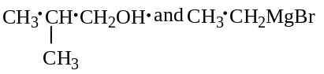
b) 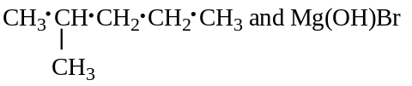
c) 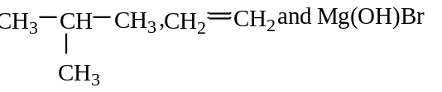
d) 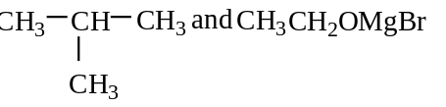

16. Strong reducing agent converts ${CHCl}_{3}$ into:
a) $C_{2}H_{2}$ b) $C_{2}H_{6}$ c) $C_{2}H_{4}$ d) ${CH}_{4}$

17. Which of the following are arranged in decreasing order of dipole moment:
a) ${CH}_{3}Cl,{CH}_{3}Br,{CH}_{3}F$ b) ${CH}_{3}Cl, {CH}_{3}F, {CH}_{3}Br$ c) ${CH}_{3}Br, {CH}_{3}Cl$,${CH}_{3}F$ d) ${CH}_{3}Br, {CH}_{3}F, {CH}_{3}Cl$

18. Fluorobenzene $(C_{6}H_{5}F)$ can be synthesised in the laboratory
a) By heating phenol with HF and KF
b) From aniline by diazotisation followed by heating the diazonium salt with $HBF_{4}$
c) By direct fluorination of benzene with$F_{2}$ gas
d) By reacting bromobenzene with NaF solution

19. 1-chlorobutane on reaction with alcoholic potash gives
a) but-1-ene b) butan-1-ol c) but-2-ene d) butan-2-ol

20. On warming with silver powder, chloroform is converted into
a) Acetylene b) Hexachloroethane
c) 1, 1, 2, 2-tetrachloroethane d) Ethylene

